ECE 3720

Timers

Section 3

Brandon Wider

Date Performed: March / 3 / 2020

Lab 7

**ABSTRACT:**

This lab discusses how to use the PIC32MX switch to the next note and how long to play each note.

**INTRODUCTION:**

The purpose of this lab is to program the microcontroller to play a song and to be able to switch notes. An interrupt must be set up for a timer to select that updates the period and plays music as necessary.

**EXPERIMENTAL PROCEDURES:**

* Set up the diagram according to the block diagram
* Ensure that the interrupts are connected correctly.

**RESULTS and DISCUSSION:**

When done correctly it the microcontroller should be able to play the notes.

**CONCLUSSION:**

In conclusion

**REFERENCES:**

Clemson University’s ECE 372 Lab 7 Powerpoint.

**FIGURES AND TABLES:**

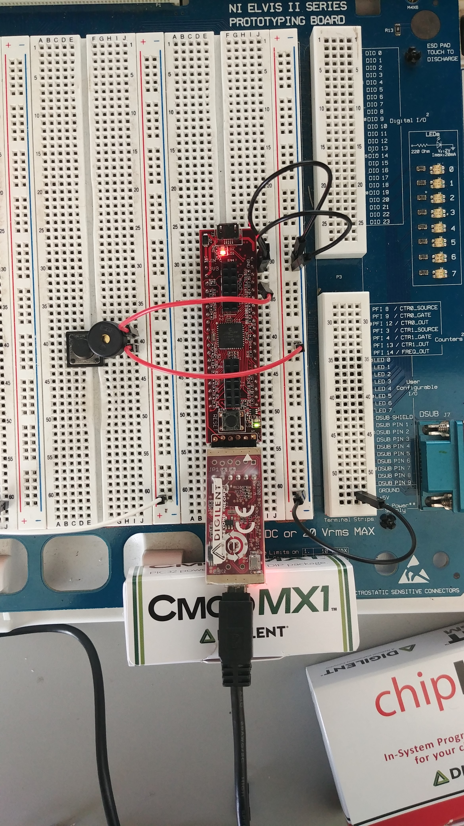

**CODE:**

#include <plib.h>  
#include <stdio.h>  
  
#pragma config FPBDIV = DIV_2  
//r is a rest. If r, don't toggle! (don't want noise to play)  
#define r 3000  
#define a 4545  
#define b 4050  
#define C 3817  
#define C_ 3610  
#define D 3402  
#define D_ 3216  
#define E 3031  
#define F 2866  
#define F_ 2703  
#define G 2551  
#define G_ 2410  
#define A 2273  
#define A_ 2146  
#define B 2025  
#define CC 1911  
#define q 400  
#define qdot q * 1.5  
#define e q/2  
#define s e/2  
#define t32 s/2  
#define sdot s+t32  
#define h q*2  
#define hdot q+e  
#define edot e+s  
#define num_notes 52  
  
int i,j;  
  
short delay[num_notes] =  
{t32,t32,t32,t32,t32,t32,t32,t32,t32,t32,s,sdot,t32,t32,  
 t32,t32,t32,t32,t32,t32,t32,t32,t32,s,sdot,t32,t32,t32,  
 t32,t32,t32,t32,t32,t32,t32,t32,s,sdot,t32,t32,t32,t32,  
 t32,t32,t32,t32,t32,t32,t32,t32,s,e};  
  
short music_notes[num_notes] =  
{b,r,B,r,F_,r,D_,r,B,F,r,D,r,C,r,CC,r,G,r,E,r,CC,G,r,  
E,r,b,r,B,r,F_,r,D_,r,B,F,r,D,r,D,E,D_,r,F,F_,G,r,G,G_,A,r,B};  
  
//Interrupt Function  
void __ISR(12)_Timer2_Handler(void) {  
 PR2 = music_notes[i];  
 if (music_notes[i] == r) {  
 //nothing happens  
 }  
 else {  
 LATBbits.LATB7 ^= 1;  
 }  
 j = j + 1;  
 IFS0bits.T3IF = 0;  
}  
main() {  
 //Setup Timers/Interrupts  
 INTEnableSystemMultiVectoredInt();  
   
 T2CONbits.ON = 0;  
 T2CONbits.TCKPS = 0x000;  
 T2CONbits.T32 = 1;  
 T2CONbits.TCS = 0;  
   
 TMR2 = 0x00;  
 PR2 = 0xFFFF;  
   
 IEC0bits.T3IE = 1;  
 IFS0bits.T3IF = 0;  
 IPC3bits.T3IP = 1;  
   
 TRISBbits.TRISB7 = 0;  
 T2CONbits.ON = 1;  
   
 while (1) {  
 for (i = 0; i < num_notes; i++) {  
 j = 0;  
 while (j < delay[i]) { //length of time to play note  
 }  
 }  
 }  
}